Results Tables:
Swathi sri G
Customers by Payment Method:
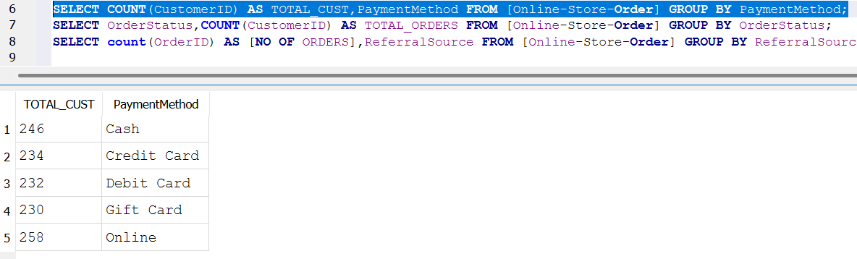

Orders by Order Status:
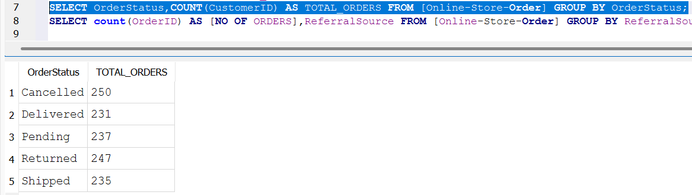

Orders by Referral Source:
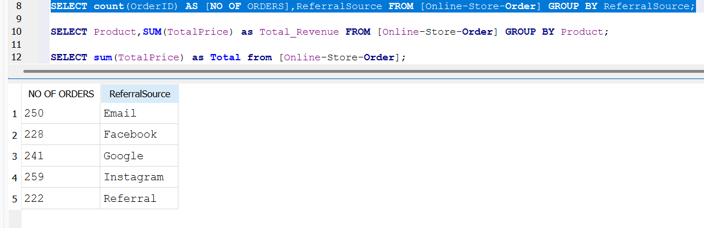

Revenue by Product:
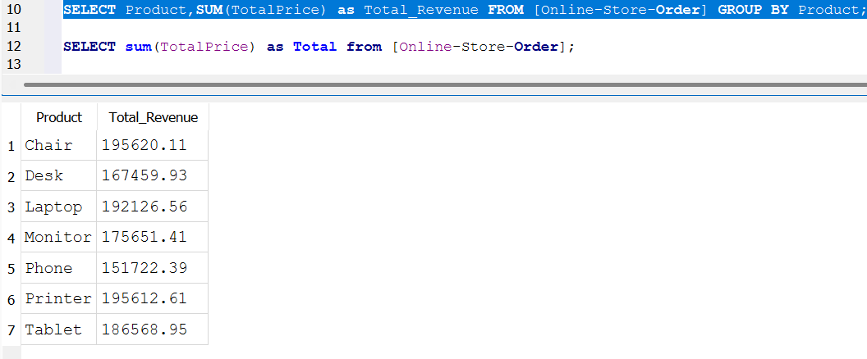
Distinct Orders by Referral Source:
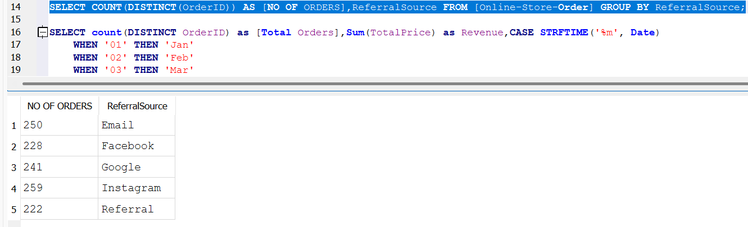

Top 5 Month-Year by Order Volume & Revenue:
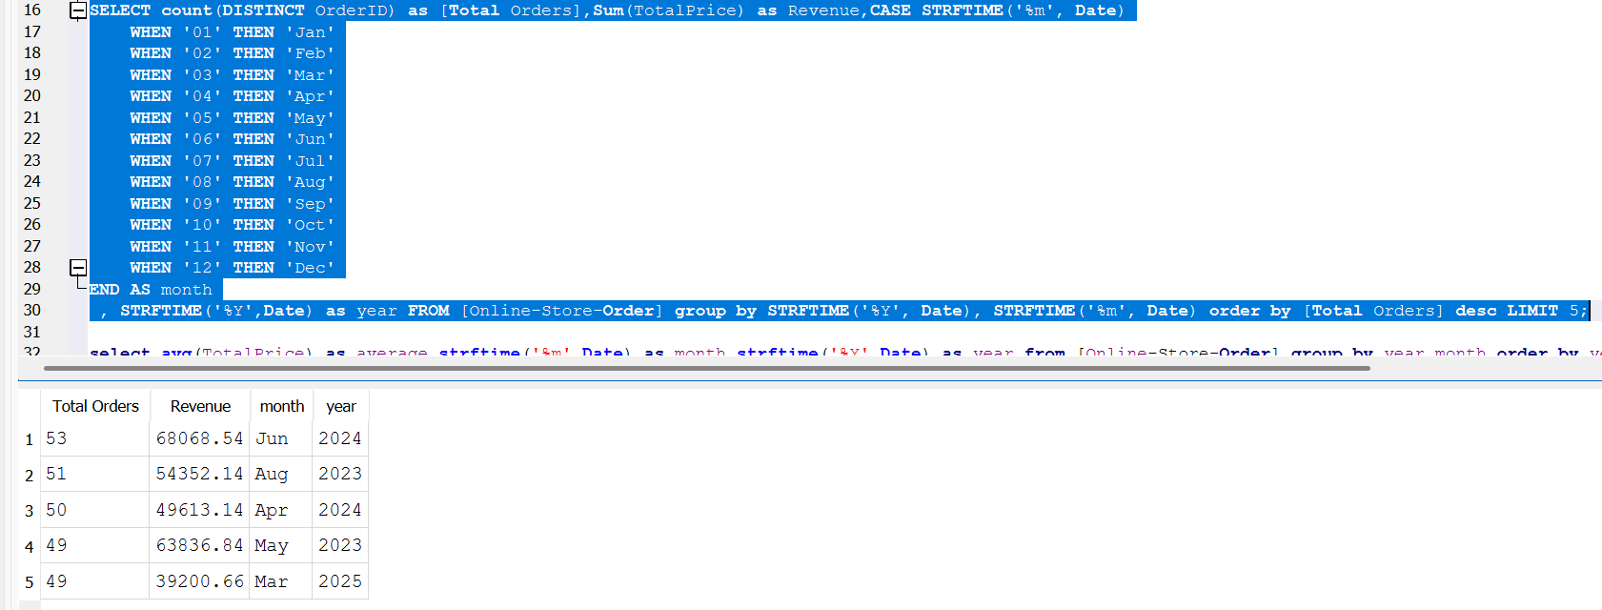

Average Revenue per Month:
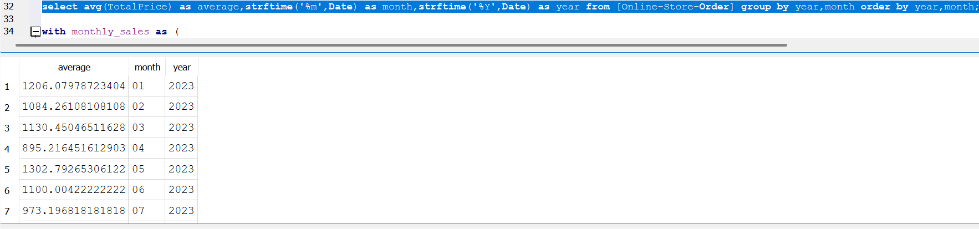

Months with Revenue Increase:
